A

Project Report on

**Heart Disease Analysis**

Submitted in partial fulfillment of completion of the course

Advanced Diploma in IT, Networking and Cloud Computing

Submitted by:

**Diptodeep Ghosh**

**Satyam Kumar Jha**

**Bikash Sharma**

Under Guidance of:

**Arpita Roy (Edunet)**

**Sayanti Manna (Edunet)**



**Abstract**

Heart disease remains a leading cause of mortality worldwide, emphasizing the pressing need for accurate prediction models and diagnostic tools. This project aims to employ advanced data analytics and machine learning techniques to analyse a comprehensive dataset of cardiovascular health parameters.

**Acknowledgement**

Firstly, our heartfelt gratitude goes to our respected trainers Arpita Roy and Sayanti Manna. This project has been an endeavour that couldn't have come to fruition without the support, guidance, and expertise of various individuals and organizations.

This include extends to the participants whose anonymized data and willingness to contribute made this research possible. Their invaluable information has been the cornerstone of this analysis, driving its depth and significance.

We would like to express our sincere appreciation to [Name/Organization] for their generous provision of the dataset used in this study.

Our deep gratitude goes to our mentor, [Arpita Roy], and class teacher [Sayanti Manna] whose insights, encouragement, and continuous support significantly shaped the direction and quality of this project.

**Team Composition and Workload Division**

Our team comprises of Three members namely Diptodeep Ghosh, Satyam Kumar Jha and Bikash Sharma.

Diptodeep Ghosh(Leader)- Responsible for overseeing the overall project coordination , planning and communication. Coordinates with other team members to gather data and documentation.

Satyam Kumar Jha(Data Analyst)- Responsible for data collection , cleaning , preprocessing , using python libraries such as Pandas , Numpy for analysis and Matplotlib , Seaborn for visualization

Bikash Sharma(Tester)- Test the code for bugs ensures that the analysis results are accurate. Validate the consistency of the data and the reliability of the code.

**Workload Division**

1. Diptodeep Ghosh: Project Planning and Conceptualization
2. Satyam Kumar Jha: Data Analyzing and Data visualization
3. Bikash Sharma: Testing and Quality assurance

**Introduction to Problem**

Heart diseases remain a critical global health concern, responsible for a substantial portion of worldwide mortality. Despite significant advancements in medical science and technology, heart diseases continue to pose a significant challenge, claiming millions of lives annually.

**Proposed Solution**

This project aims to develop a robust and accurate predictive model for heart disease based on comprehensive analysis of a diverse dataset encompassing a wide array of cardiovascular health parameters. Leveraging advanced data analytics and machine learning techniques, the following steps will be undertaken:

The ultimate goal of this proposed solution is to deliver a predictive model that not only demonstrates high accuracy but also provides actionable insights for healthcare practitioners, aiding in proactive measures for heart disease prevention and management.

**Requirements**

Technology Stack - Programming Language

1. Python

Data Analysis and Visualization:

1. Jupyter Notebooks

Libraries and Frameworks:

1. Pandas, NumPy, Matplotlib, Seaborn

Hardware -

1. CPU and RAM
2. Reliable internet connectivity and security measures to protect the system

Software - Operating System, Python Environment,Jupyter Notebook , Web Server

Deployment Environment

We can initially deploy on our local PC’s.

**User Requirements**

1. PCs
2. Internet Access
3. Supported Browser
4. User-friendly interfaces to input personal health data , lifestyle information and symptoms.

**Implementation Details**

Implementation of Heart Disease Analysis Project involves several steps including data loading, cleaning, analysis and visualization.

Step 1- Download csv file from kaggle.

Step 2- Extract the file.

Step 3- Open JUPYTER NOTEBOOK.

Step 4- Import all the necessary libraries NumPy, Pandas, Seaborn.

Step 5- Read the whole csv file [df = pd.read_csv(‘file_name.csv’)

Print(df)]

Step 6-

# to find the rows and columns of the dataframe.

print(df.shape)

# To find what are the column index of the dataframe

nd the datatype of the CSV file

print(df.columns)

# to fiprint(df.dtypes)

# To find the information about the file like storage, datatypes, class etc.

df.info()

# To see the last 10 data from the dataframe

print(df.tail(n=10))

**Testing**

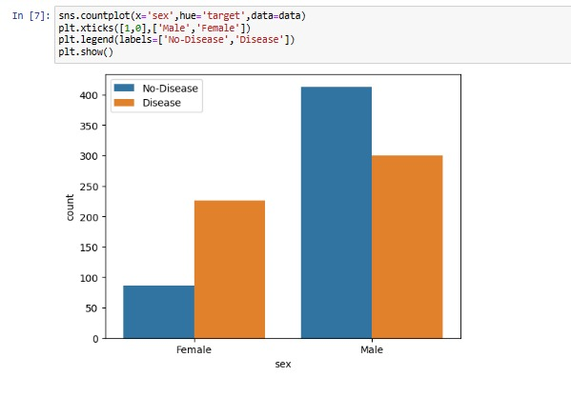

**Deployment**

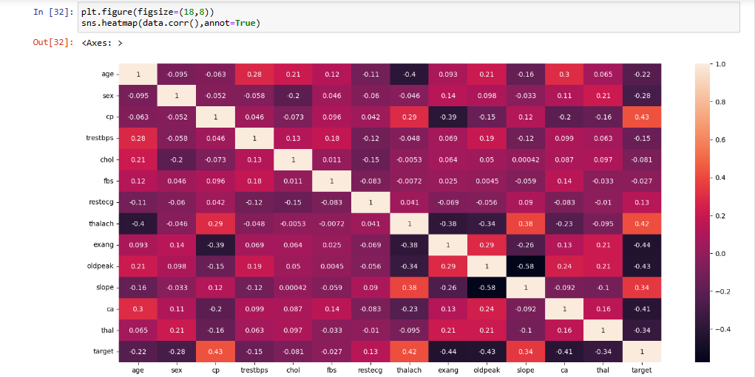

**Future Scope**

Looking at the future scope for users involved in a heart disease analysis project involves anticipating advancements in technology, research, and healthcare. Here are some potential future requirements for different user roles:

1. Integration of AI-powered decision support systems for real-time analysis of patient data, aiding in quicker and more accurate diagnoses.
2. Access to larger, more diverse datasets encompassing genetic, environmental, and lifestyle factors to refine predictive models and treatment strategies.
3. Utilization of mobile health applications for personalized health monitoring, feedback, and intervention based on real-time data.
4. Implementation of robust cybersecurity measures to safeguard patient data against evolving threats.

Incorporating these future-oriented requirements can help ensure that a heart disease analysis project remains relevant and effective in an evolving healthcare landscape.

**Conclusion**

In conclusion, a heart disease analysis project stands as a critical endeavor in addressing one of the leading causes of mortality worldwide. The complexities surrounding heart disease demand a multifaceted approach, leveraging technological advancements and medical expertise to improve prevention, diagnosis, and treatment strategies.

1. Throughout this project, a focus on user-centric design ensures that medical professionals have access to cutting-edge diagnostic tools and decision support systems.
2. As we envision the future, this project remains poised to evolve alongside technological breakthroughs and advancements in healthcare.
3. In essence, this heart disease analysis project serves as a beacon of progress, uniting diverse expertise and resources to combat a global health challenge.

**Screenshot of Project**

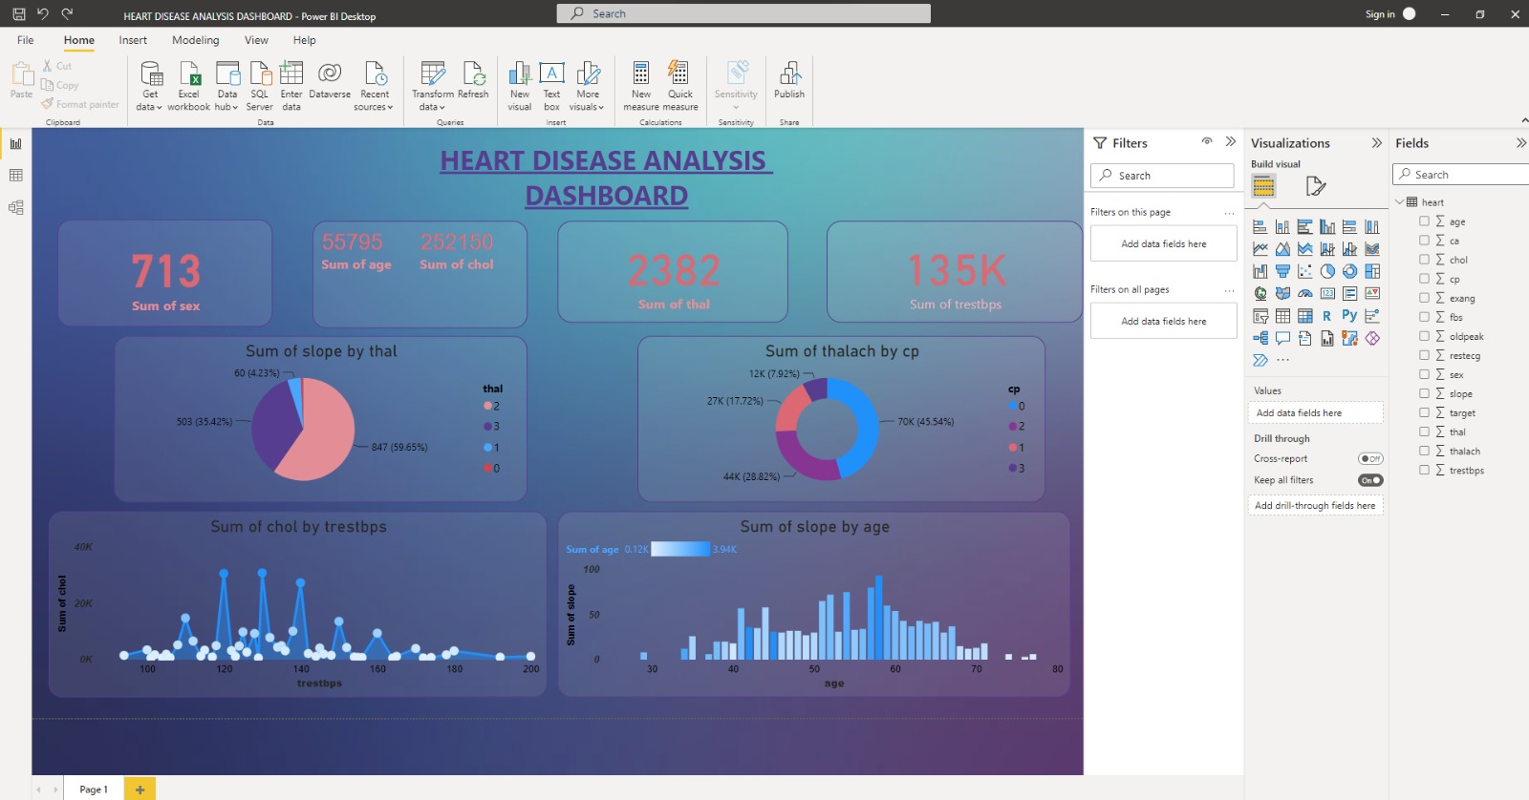

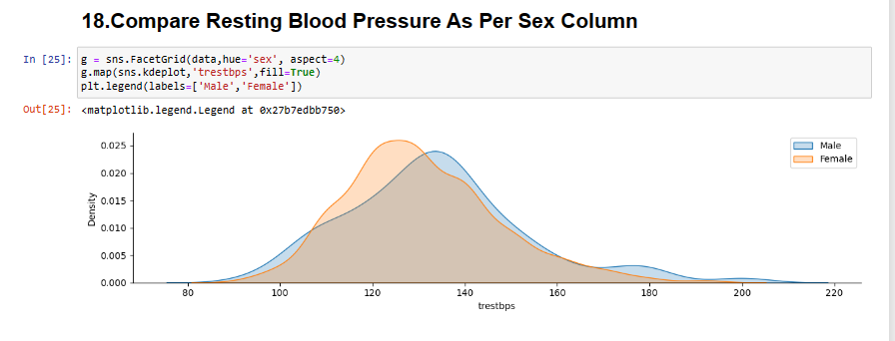

**References:**

[www.kaggle.com](http://www.kaggle.com)

<https://www.youtube.com/watch?v=DkdHmc1r4gk>

[www.google.com](http://www.google.com)